Statinf Project Part 1 - Simulation

Simulations

I ran a total of three simulations based on the exponential distribution. For all simulations lambda was set to 0.2. First I generated 1000 randoms from the exponential distribution and assigned it to the variable exp.dist:

> exp.dist <- rexp(1000, 0.2)

Afterwards I generated 1000 means of 40 randoms from the exponential disctribution and assigned it to the variable means:

> means <- NULL

> for (i in 1:1000) {means = c(means, mean(rexp(40, 0.2)))}

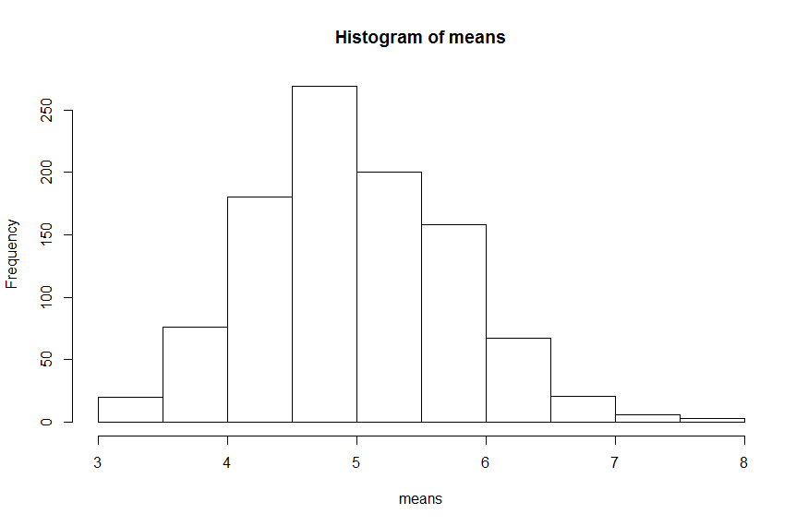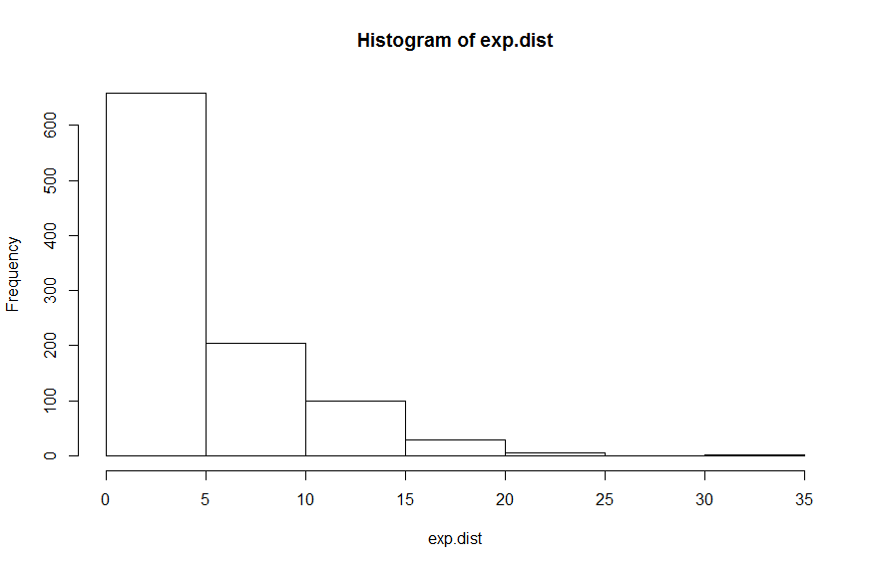Below are the histograms for both exp.dist and means.

Finally I generated the variance of 40 randoms from the exponential distributions 1000 times and assigned the resulting values to the variable vars.

> vars <- NULL

> for (i in 1:1000) {vars = c(vars, var(rexp(40, 0.2)))}

Sample Mean vs. Theoretical Mean

Given a lambda of 0.2, the theoretical mean of both distributions is 5. Taking the mean of exp.dist and means returns 4.696 and 4.971 respectively.

> mean(exp.dist)

[1] 4.695776

> mean(means)

[1] 4.970511

Both means are indicated graphically on the histograms above.

Sample Variance vs. Theoretical Variance

The theoretical variance of the exponential distribution with lambda = 0.2 is: 5^2 = 25. The variance values for the three simulations are close to this.

> var(exp.dist)

[1] 22.37157

> mean(vars)

[1] 24.07469

Firstly the variance of exp.dist is 22.37. This is unexpectedly low, but still close enough to the expected value of 25. The mean of vars shows that on average the variance of 1000 groups of 40 random, exponentially distributed values is 24.07, which is very close to our expected value.

Distribution

While the histogram of means is not perfectly normally distributed it does look like it roughly follows a normal distribution. Besides visual comparison, the quantiles of means can be compared to the quantiles of a normal distribution with mean(means) and sd(means):

> quantile(means, c(0.01, 0.05, 0.1, 0.9, 0.95, 0.099))

1% 5% 10% 90% 95% 9.9%

3.373305 3.738138 4.012117 5.972792 6.325825 4.011567

> qnorm(c(0.01, 0.05, 0.1, 0.9, 0.95, 0.099), mean = mean(means), sd = sd(means))

[1] 3.156318 3.687779 3.971098 5.969924 6.253244 3.966638

These values support the initial observation that the means of 40 randoms from the exponential distribution follow a normal distribution.